LAB05 - I/O CONFIG, GPIO, Using GPIO for RGB LED control.
In this LAB we will configure GPIO to work with RGB LED. Also we will control LED to make some color patterns.
Simplified wiring diagram is shown on picture below. Full wiring may be found in "LPC4088 Experiment Base Board Schematic ( LPC4088_Experiment_Base_Board_revA.pdf )"
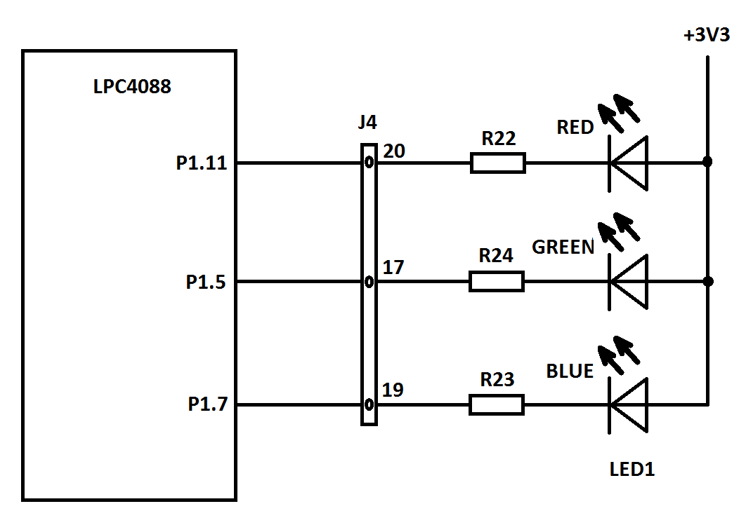
LED1 is a RGB light emission diode. Physically all 3 channels are placed in the same case. Common anode is connected to 3.3 V power source. 3 separate cathodes are connected throw current-limiter resistors (R22, R23 and R24) and connector J4 to 3 separate pins of LPC4088 ARM processor.
Connections:
Device | LPC4088 pin | J3/J4 pins
LED1 - RED | P1.11 | J4-20
LED1 – GREEN | P1.5 | J4-17
LED1 – BLUE | P1.7 | J4-19
The diode emits the light when some current going throw. The voltage on CPU pin may be +3.3 V if the pin is set to 'logical 1' and 0V if the pin is in 'Logical 0' state. If the pin is high (logical 1) the voltage on anode and cathode will be the same (+3.3 V). So, no current will be go throw and LED will be dark. If the CPU pin will be in Logical 0 state, the voltage on cathode will be 0V. On anode it will be 3.3V from power source, the current will go throw diode and diode will be bright. So, by setting the CPU pin to 1 or 0 we can turn the diode on or off.
Important!
- Set PIN LOW to turn LED ON
- Set PIN HIGH to turn LED OFF
Different combination of RED, BLUE and GREEN lights will give you different colors. For example, if all 3 R, G and B are ON, you will see white light.
The placement of related parts on the board is shown on the picture below.
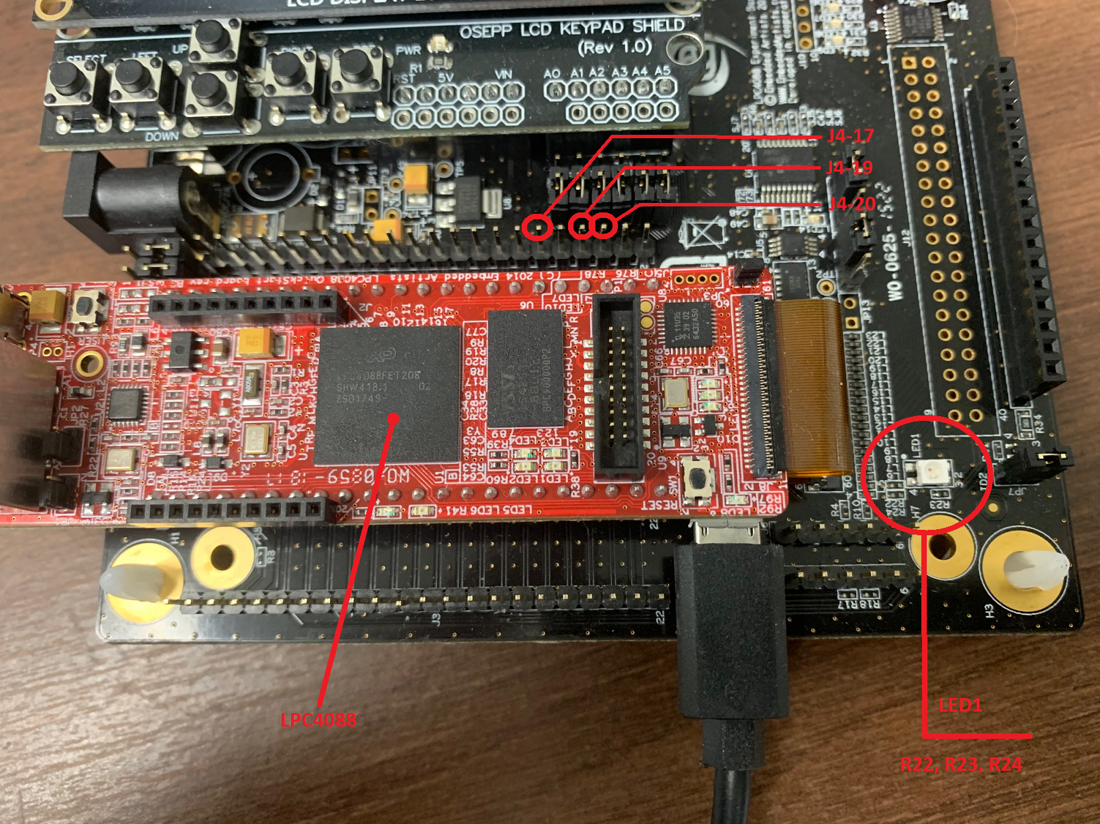
Be aware: The RGB LED is very bright! It is recommended to cover it with some piece of white paper!
Recommended readings:
- UM10562 - LPC408x/407x User manual ( UM10562.pdf ) – Chapters 7 and 8.
- LPC4088 Quick Start Board Schematic. ( LPC4088_QuickStart_Board_revB.pdf )
- LPC4088 Experiment Base Board Schematic ( LPC4088_Experiment_Base_Board_revA.pdf )
Let's start the project!
1. Create the directory named 'LPC4088' inside of yours “YourId_CS107” root folder.
2. Download 'LPC4088.zip' into your 'Your_CS107_Route\LPC4088' directory and unzip it. "*.s" files contains lot of definitions for LPC4088 processor. They may be helpful! Files are 'read-only'. Please do not change its status and do not edit it. If you have edited some file(s), ask for free replacement. The ‘startup’ file ‘startup_LPC407x_8x_177x_8x.s’ now also can be found in ‘\LPC4088’ folder.
3. Create the directory named 'Lab05’. Download, unzip and copy the file 'Template_Lab05.s' into your 'Lab05' directory. Rename 'Template_Lab05.s' to 'JoeTheStudent_Lab05_PartA.s' where 'JoeTheStudent' is your name or canvas login. Open 'Keil uVision' and create new project 'Lab05' like you did it for Lab01, Lab02, Lab03 and Lab04. Use all usual project's settings except one!
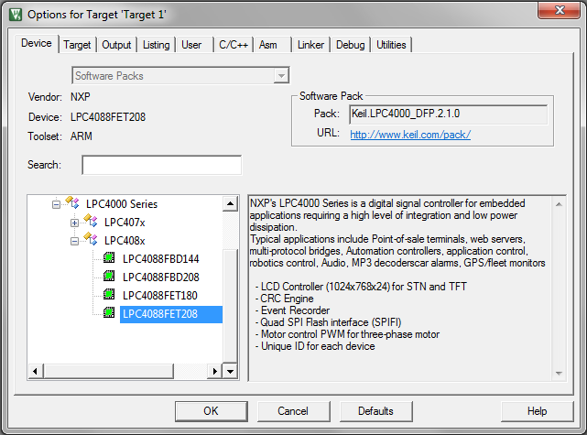
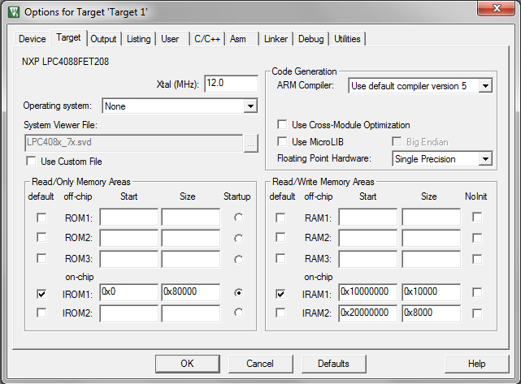
Important: Include your ' YourId_CS107\LPC4088' directory into 'Include path'!
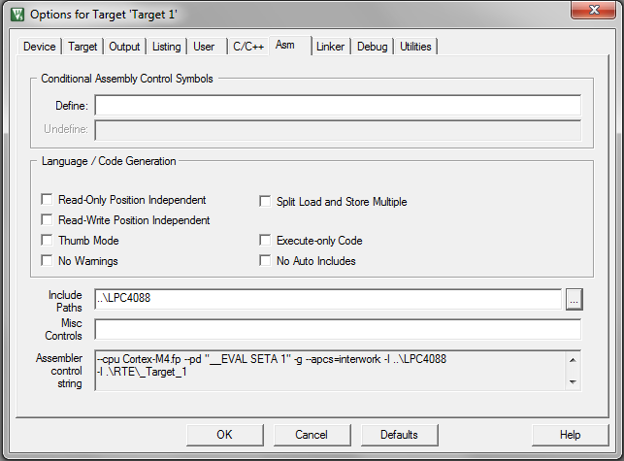
On ‘Asm’ tab, go to ‘Include Paths’ edit box and type ‘..\LPC4088’. It is important!
All other settings are as usual.
Important: Unlike Lab02, Lab03 and Lab04, this project will not work with 'Simulator'. Real board is required!
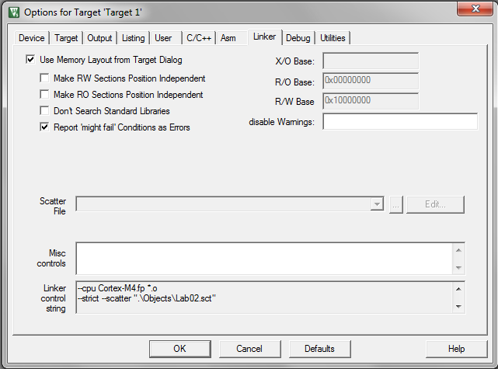
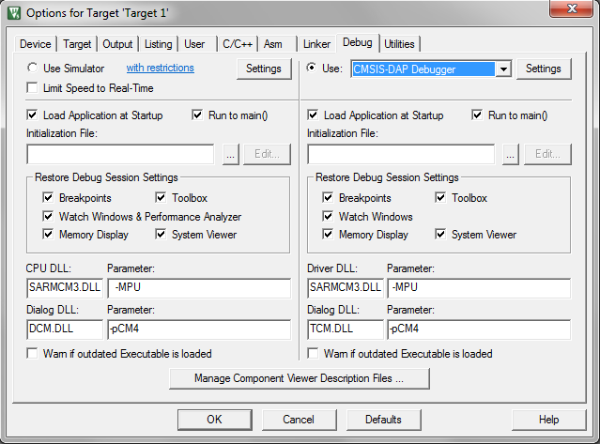
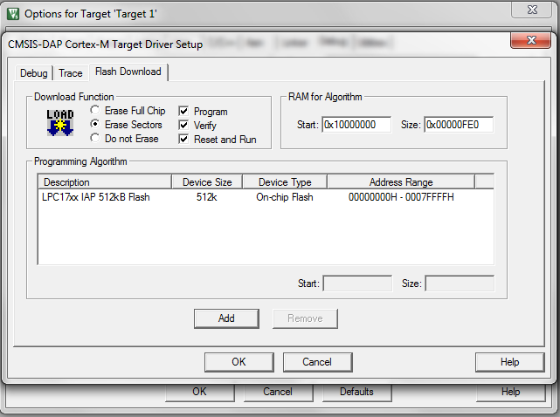

4. Add 'JoeTheStudent_Lab05_PartA.s' and 'LPC4088\startup_LPC407x_8x_177x_8x.s' files into your project. In ‘Add File’ dialog you will need to navigate to ‘..\LPC4088’ directory. Use standard ‘Up One Level’ button. Open 'JoeTheStudent_Lab05.s' file.
You do not need to add all '*.s' files in 'LPC4088' directory into your project. The assembler will do it automatically.
5. We will start with simplest task. Toggle 1, 2 or 3 LED’s pin(s) simultaneously. So, depend on pin(s) selected, you will have blinking red, blue, green, white or some other light. The general algorithm is presented on the picture:
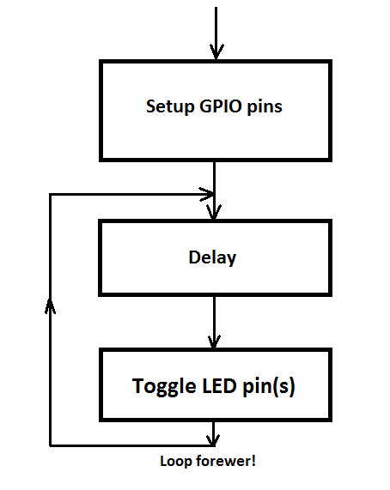

6. Good example is Lab01. Actually, Lab01 is doing the same task, but using different LEDs and Pins… You may use Lab01 as reference and example for your project.
7. In this Lab you will use constant definitions form the file 'BOARD.S'. You may open the 'BOARD.S' file in your project. To do it:
- Build your project (F7). The template file is 'empty' yet, but it should produce no errors.
- You will see [+] mark next to 'JoeTheStudent_Lab05_PartA.s' file in the 'Project' window.
- Click on [+]. You will see many '.S' files that the assembler automatically added to your project.
- 'Double click' on 'BOARD.S' file.
The constant definitions for Lab 5 are:
;
; Base Board RGB Led (LED1) GPIO Interface...
;
; RGB_R - P1_11
; RGB_G - P1_5
; RGB_B - P1_7

RGBLED_IOCONF_PORT EQU IOCON_P1_BASE
RGBLED_R_IOCONF_PIN EQU PIN11
RGBLED_G_IOCONF_PIN EQU PIN5
RGBLED_B_IOCONF_PIN EQU PIN7
RGBLED_R_IOCONF_CFG EQU (D_FUNC_0)
RGBLED_G_IOCONF_CFG EQU (W_FUNC_0:OR:W_ADMODE_DGT)
RGBLED_B_IOCONF_CFG EQU (W_FUNC_0:OR:W_ADMODE_DGT)

RGBLED_PORT EQU GPIO_P1_BASE
RGBLED_R_BIT EQU BIT11
RGBLED_G_BIT EQU BIT5
RGBLED_B_BIT EQU BIT7
RGBLED_ON EQU CLR
RGBLED_OFF EQU SET

Also you will use some constants defined in ‘IOCONDEF.S’ and ‘GPIODEF.S’ files. You may open those files exactly the same way you did it for ‘BOARD.S’
8. First, we need to setup CPU pins, used to control LED. We will do it in the ‘System Init routine’. Please, locate this line in your 'JoeTheStudent_Lab05.s'. The procedure begins with label ‘SystemInit’ and ends by instruction ‘ BX LR’. All device initialization should be between those lines.
Note: When CPU is powered ON, or Reset signal is coming from ‘uVision’ the CPU starts executing code starting from ‘Reset_Handler’ address (see ‘startup_LPC407x_8x_177x_8x.s'). First, ‘Reset Handler’ procedure calls ‘SystemInit’ and then, pass the control to ‘__main’ procedure.
8.A. Locate the lines:
;
; Configure GPIO Pins
;
; --- Write your pin configuration code here....

(It is right below ‘SystemInit’ label).
You already know that you have to use IOCON registers to say to CPU what functionality some particular pin will have. Please refers to slides ##11-30 of Lecture presentation for details.
The slide #30 shows how to setup pin for RED LED using definitions from 'BOARD.S' file (Base-offset method). So, replace the line '; --- Write your pin configuration code here....' by processor's instructions:

LDR R0, =RGBLED_IOCONF_PORT ; Base Addr. Of IOCON registers
MOV R1, #RGBLED_R_IOCONF_CFG ; Conf. bits
STR R1, [R0, #RGBLED_R_IOCONF_PIN] ; Write conf. bits to register..

8.B. Do the same for GREEN and BLUE LED pins. Use 'RGBLED_G_IOCONF_PIN ', 'RGBLED_B_IOCONF_PIN ', 'RGBLED_G_IOCONF_CFG' and 'RGBLED_B_IOCONF_CFG 'instead of 'RGBLED_R_IOCONF_PIN ' and 'RGBLED_R_IOCONF_CFG'. All pins are 'Port 1' pins, so you do not need to reload R0 with base address.
9. Now we have to set all 3 LED lines to ‘output’ (default mode for all digital lines is ‘input’). IOCON cannot do it. You may wish to read Chapter 8 of "UM10562 - LPC408x/407x User manual" or review slides ##32-41 of Lecture presentation.
The great example how to set 3 lines for 'output' is on the slide #39 (very first example on the top of the slide). You just have to slightly modify it to use with definitions from 'BOARD.S' file.
9.A. Locate the lines:
; You may want to define some constant(s) for delay and/or bitmask.
; if so, do it below this lines or uncomment following lines and
; type proper constant(s) instead of '??????'
;
main_delay EQU 2500000
;RGB_PINS EQU (???????)

(This is right above 'SystemInit' label)
9.B. Below ';RGB_PINS... ' type:
RGB_DIR_MASK EQU (RGBLED_R_BIT:OR:RGBLED_G_BIT:OR:RGBLED_B_BIT)

This is will be your bitmask to use in DIR GPIO register.
9.C. Locate the lines:
;
; Set pins for output
;
; --- Write your code here....

9.D. Replace '; --- Write your code here....' by:

LDR R0, =RGBLED_PORT ; R0 = Port 1 Base address
LDR R1, =RGB_DIR_MASK ; R1 = direction mask
LDR R2, [R0, #DIR] ; Read DIR1 register.
ORR R2, R2, R1 ; R2 = R2 OR R1
STR R2, [R0, #DIR] ; Store result to DIR1
Please note:
- We cannot use previous base address in R0 because IOCON module is not GPIO module! As soon as we told to processor (by FUNC field of IOCON register) the pins are under control of GPIO, we have to work with the pin by GPIO registers. So, we have to store base address of GPIO into R0.
- 'LDR R1, =RGB_DIR_MASK' is much better than 'MOV R1, #RGB_DIR_MASK' because RGB_DIR_MASK may be a 'bad constant'.
- We are using 'Read-Modify-Write' method because we do not want accidentally change the directions for all other pins of Port 1. Other pins may be used by other devices, in other parts of software, etc. We do not want to introduce any possible errors into project.
- Since we have to set bits to '1', we are using the instruction 'ORR'. It is logical OR function. OR with '1' always gives us resulting '1'.
10. Now we have to turn all LEDs OFF. You know, you may use GPIO register 'SET' to set selected pin(s) to '1' (3.3V) or you may use GPIO register 'CLR' to set selected pin(s) to '0' (0V). And you have to use bitmasks in 'SET' and 'CLR' registers. '1' in bitmask change the state of the pin, '0' leave the state unchanged.
We need to turn off all 3 LEDs, so we can use the same 'RGB_DIR_MASK' we have used for direction setting. Also, we have noted above, to turn LED off, the pin should be in '1' state, i. e. generates 3.3V. So, the GPIO register should be 'SET'. To simplify the task even more, we have constant 'RGBLED_OFF ' (Actually, it was defined as 'SET'). You may use this constant in your code.
The example how to set 3 lines into '1's is also on the Slide #39 of Lecture presentation. You may just slightly modify it to use your constants.
10.A. Locate the lines:
; Turn all off!
;
; --- Write your code to turn all 3 LEDs off here (optional)....
10.B. Replace '; --- Write your code here....' by:

STR R1, [R0, #RGBLED_OFF] ; Turn all LEDs OFF…
Please note:
- You already have correct base address in R0, and correct bitmask in R1. You do not need to write those numbers into R0 and R1 again.
- You may use 'Write all at once' method for 'RGBLED_OFF' because only pins with '1' in bitmask will be affected.
11. Now you can build your project, load it into board and run (or debug). The LED should be dark. (By step-by-step execution, the LED will be white after direction of pins turned to 'output'. But 'Turn all off!' code should return it to dark state.
12. Now is the time to work for ‘__main’ procedure. Your program will toggle one, two or all three LEDs simultaneously. And your program will be placed here – in ‘__main’ procedure. Like any computer program you will need to use some ‘variables’ and/or ‘constants’. Inside of LPC4088 CPU you have 15 registers. Registers R13 (SP), R14(LR) and R15(PC) are special registers and you cannot use it. R3 is used as delay counter in this project. But R0 – R2 and R4 – R12 are ‘general purposes’ registers and you may use it like you wish. For example, you may use it to store values of your ‘variables’ and ‘constants’. 12 variables/constants – it is a quite enough!
A good planning and register assignment is a key to success of the project!
You will use two 'constants' in your project: Base address of GPIO port and 'bitmap' that will define which LED(s) you will toggle.
12.A. Locate the line:
;RGB_PINS EQU (???????)
Uncomment it and replace '?????' by 'RGBLED_R_BIT:OR:RGBLED_G_BIT:OR:RGBLED_B_BIT'. It will give you bright white color (Later you may use some another combinations: ' RGBLED_R_BIT' will give you Red light, 'RGBLED_G_BIT' - Green, you may try 'RGBLED_G_BIT:OR:RGBLED_B_BIT', etc.)
12.B. Locate the lines:
__main
;
; --- You may write some additional initialization code here...

12.C. Replace ‘; --- You may write some additional...’ by:
LDR R1, =RGBLED_PORT ; R1 is base address of LEDs GPIO Port
LDR R2, =RGB_PINS ; R2 is bitmap

13. ‘Delay’ loop is preprogrammed for you. Do not change it.
The constant ‘main_delay’ is declared before ‘SystemInit’ procedure as 250000. It is a good starting point for 12MHz default clock frequency. You may adjust it later. Lower numbers will give you a fast blinking, higher numbers - slower speed.
14. The last step is to write the code that will toggle LED pin(s). It may be done by many different ways. We will use the simplest one.
Ok, we have to ‘toggle’ the pin… What does it mean? If the pin is low, it should go high and vice-versa. Or: if (pin==0) then pin = 1 else pin = 0. Can we do it without conditional operators? Yes. You have to remember ‘exclusive OR’ operator.

A | B | A XOR B
0 | 0 | 0
0 | 1 | 1
1 | 0 | 1
1 | 1 | 0

As we can see, XOR of operand with ‘1’ gives us inverted operand. This is exactly what we need! So, algorithm will be:
a. Read PIN register into some register Rx.
b. Do XOR of Rx with selected bitmask (1’s in selected LED’s bits, i.e. Bits 5, 7, 11 for all 3 LEDs)
c. Write Rx into PIN.
The example is on Slide #40 of Lecture presentation (second one).
14.A. Locate the lines:
;
; Invert pin(s)
;
; --- Write your code to invert pin(s) here...
14.B. Replace ‘; --- Write your code to invert pin(s) here...’ by:
LDR R0, [R1, #PIN] ; Load PIN register into R0
EOR R0, R2 ; XOR with bitmask
STR R0, [R1, #PIN] ; Store R0 back to PIN register

Please note:
This is a 'Read-Modify-Write' method. Only pin(s) selected by 'bitmask' (R2) will be affected. Other pins will remain unchanged. This is a safest way to make hardware-related projects.
15. Finish your code and debug it. Get white light blinking!
Play with different combinations of RED, GREEN and BLUE channels and with delay. Let your LED(s) blinks faster or slower.
You may try to use some different ways to turn LED(s) ON and OFF. Some examples are on Slides #39 and #40 of Lecture presentation.
16. When you done submit your project to ‘Canvas’.
17. Then you may try to do ‘Part B’: let RED, GREEN and BLUE LEDs blinks independently, each with own frequency. It may give some interesting effects like Christmas tree lights.
You may make a copy of your 'JoeTheStudent_Lab05_PartA.s' file, rename it to 'JoeTheStudent_Lab05_PartB.s' and include into your project. Then 'right click' on 'JoeTheStudent_Lab05_PartA.s' file in 'Project' window, select 'Options for the file 'JoeTheStudent_Lab05_PartA.s'...', uncheck 'Include in Target Build' and click 'Ok'.
18. The algorithm shown on the picture below. You will need three separate counters, one per color. Each ‘color counter’ will set blinks frequency for corresponding light. The ‘master_delay’ value should be less than the value used in ‘part A’. You can start with 250000 / Na, where Na is average of yours ‘Color counters’. You may get some interesting effects if all three counters will be close together, but slightly different. For example: 20, 21, and 22 (master_delay will be 250000/20 = 12500). Or: 100, 101, 102 (master_delay = 50000). 31, 59 and 83 (master_delay = 50000) are good numbers also.
You may use any technique (‘Read-Modify-Write’ PIN register, masked PIN register or use SET/CLR registers for selected pin(s)) to control LEDs. Just make sure you are not changing all LEDs at the same time (i. e. if you are changing state of RED LED because of RedCounter == 0, you are not changing the status of BLUE and GREEN LEDs too).
You may see the approximate result of your 'Part_B' project on video posted on 'Canvas'
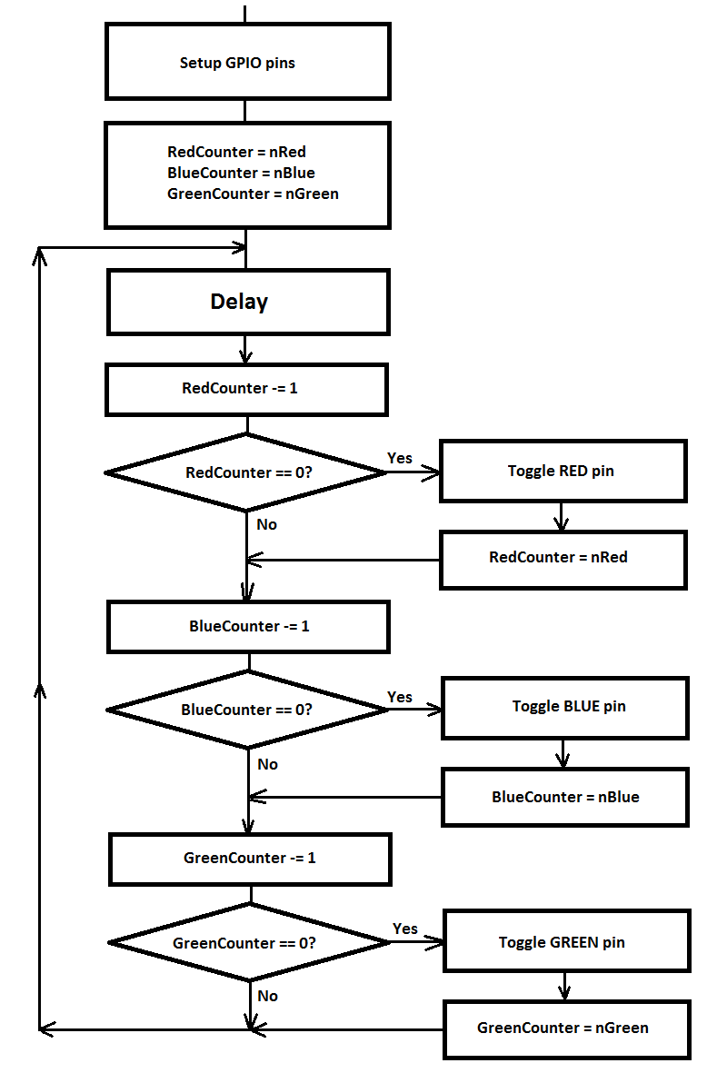
19. When done, rename the source file as ‘…_Part_B.s’ and submit both ‘…_Part_A.s’ and ‘_Part_B.s’ files to Canvas.
20. Keep your Lab05 files! May be you will use it in next Lab(s).

Documents:
- LPC4088 Quick Start Board Schematic. ( LPC4088_QuickStart_Board_revB.pdf )
- LPC4088 Experiment Base Board Schematic ( LPC4088_Experiment_Base_Board_revA.pdf )
- LPC4088 Experiment Base Board User’s Guide ( LPC4088_Experiment_BB_Users_Guide.pdf )
- UM10562 - LPC408x/407x User manual ( UM10562.pdf )
- Cortex™-M4 Devices Generic User Guide ( DUI0553.pdf )
- Cortex-M4 Revision r0p0 Technical Reference Manual ( DDI0439B_cortex_m4_r0p0_trm.pdf )

